GUESS PAPER-2013
CLASS-X
SUBJECT- Mathematics
Design of the Question Paper for Summative II
Type of Questions | Marks per Question | Total Number of Questions | Total Marks
MCQ | 1 | 8 | 8
VSQ | 2 | 6 | 12
SQ | 3 | 10 | 30
LQ | 4 | 10 | 40
Total |  | 34 | 90

Blue Print of the Question Paper for Summative II
S.No. | Units | MCQ | VSQ | SQ | LQ | Total Marks
1 | Algebra | 1(1) | 4(2) | 6(2) | 12(3) | 23(8)
2 | Geometry | 3(3) | 4(2) | 6(2) | 4(1) | 17(8)
3 | Mensuration | 1(1) | 4(2) | 6(2) | 12(3) | 23(8)
4 | Trigonometry | 1(1) | - | 3(1) | 4(1) | 8(3)
5 | Coordinate Geometry | 1(1) | - | 6(2) | 4(1) | 11(4)
6 | Probability | 1(1) | - | 3(1) | 4(1) | 8(3)
 | Total | 8(8) | 12(6) | 30(10) | 40(10) | 90(34)

Summative Assessment II
MATHEMATICS
Time: 3 hours M.M. = 90
GENERAL INSTRUCTIONS
- All questions are compulsory.
- The paper consists of 34 questions divided into four sections A, B, C and D.
- Section A contains 8 MCQs of 1 mark each. Section B contains 6 questions of 2 marks each. Section C contains 10 questions of 3 marks each. Section D contains 10 questions of 4 marks each.
- Question number 1 to 8 in Section A are multiple choice questions where you are required to select any one correct option out of the given four.
- There is no overall choice however internal choices have been provided in 1 question of 2 marks each, 3 questions of 3 marks each and 2 questions of 4 marks each. You have to attempt only one of the alternatives in all such questions
- Use of calculator is not permitted.
SECTION-A
- A die is thrown, the probability of getting a number less than 3 and greater than 2 is
  - 0
  - 1
  - 1/3
  - 2/3
- The perimeter of the ends of a frustum are 48 cm and 36 cm respectively. If the height of the frustum is 11 cm, then volume of the frustum is
  - 155 π cm³
  - 200π cm³
  - 1554 cm³
  - 5154 cm³
- A right angled triangle of sides AB = 6 cm and BC = 8 cm is drawn. A circle taking side BC as a diameter is drawn. The length of tangent from point A to the circle is
  - 8 cm
  - 6 cm
  - 10 cm
  - none of these
- An equation equivalent to the quadratic equation x² - 6x + 5 = 0 is
  - 6x² - 5x + 1 = 0
  - x² - 5x + 6 = 0
  - 5x² - 6x + 1 = 0
  - none of these
- The common point of the tangent and the circle is called
  - golden point
  - point of contact
  - point of intersection
  - degenerate point
- To construct a triangle similar to a given ∆ABC with its side 3 / 7 of the corresponding sides of ∆ABC, first draw a ray BX such that angle CBX is an acute angle and X lies on the opposite side of A with respect to BC. Then locate points B_{I}, B_{z}, B₃, ••• on BX at equal distances and next step is to join
  - B₁₀D to C
  - B₃ to C
  - B₇ to C
  - B₄ to C
- If two towers of height h₁ and h₂ subtend angles of 60° and 30° respectively at the mid-point of the line joining their feet, then h₁: h₂ =
  - 1 : 2
  - 1 : 3
  - 2 : I
  - 3 : 1
- The vertices of a triangle are (0, 0), (3, 0) and (0, 4). Its ortho centre is at
  - (0, 3)
  - (4, 0)
  - (0, 0)
  - (3, 4)
SECTION B
- Find the value of p for which the quadratic equation x² -2px + 1 = 0 has no real roots.
- Find the 10th term from the end of the AP 4, 9, 14, ... ,254.
Or,
Which term of the AP 24, 21, 18, 15, ... is the first negative term?
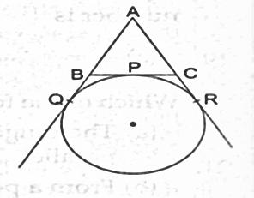
- A circle is touching the side BC of a ∆ ABC at P and is touching AB and AC when produced at Q and R respectively. Prove that AQ = ½ (perimeter of ∆ABC).
- Two vertices of a ∆ ABCare given by A(6, 4) and B( -2, 2)and its centroid is G(3, 4). Find the coordinates of its third vertex C.
- A box contains 150 oranges. If one orange is taken out from the box at random and the probability of its being rotten is 0.06, then find the number of good oranges in the box.
- A toy is in the form of a cone mounted on a hemisphere of common base radius 7 cm. The total height of the toy is 31 cm. Find the total surface area of the toy.
SECTION-C
- Two numbers differ by 3 and their product is 504, find the numbers.
- Find the sum of the first 25 terms of an AP whose n^{th} term is given by t_{n} = 7 - 3n.
Or
Which term of the Arithmetic Progression 3, 10, 17, .. , will be 84 more than its 13th term?
- Determine the ratio in which the point (- 6, a) divides the join of A (- 3, - 1) and B ( - 8, 9). Also find the value of a.
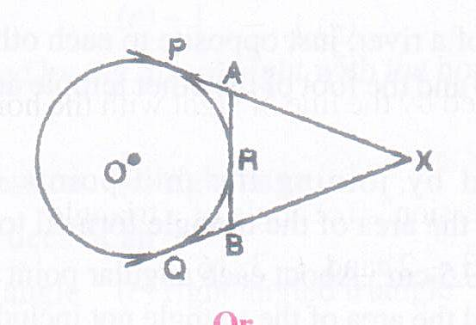
- The line joining the points (2, 1) and (5, -8) is trisected at the points P and Q. If point P lies on the line 2x - y + k = 0, find the value of k.
- In figure, XP and XQ are two tangents to a circle with centre O from a point X outside the circle. ARB is tangent to circle at R. Prove that XA + AR = XB + BR.
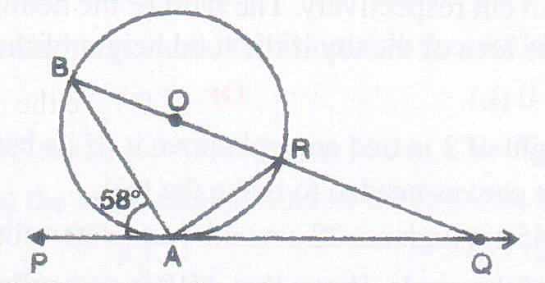
Or
In figure, O is the centre of the circle, PQ is a tangent to the circle at A. If angle PAB = 58°, find angle ABQ and angle AQB.
- Draw a circle of radius 3 cm. From a point P, 6 cm away from its centre, construct a pair of tangents to the circle. Measure the lengths of the tangents.
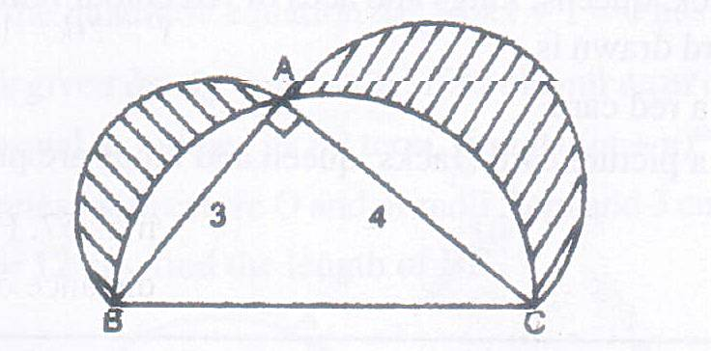
- From the top of a building 15 m high, the angle of elevation of the top of a tower is found to be 30°. From the bottom of the' same building, the angle of elevation of the top of the tower is found to be 45°. Determine the height of the tower and the distance between the tower and the building.
- In figure, ABC is a right-angled triangle, right-angled at A. Semicircles are drawn on AB, AC and BC as diameters. Find the area of the shaded region.
- A hemispherical bowl of internal diameter 30 cm contains some liquid. This liquid is to be filled into cylindrical shaped bottles each of diameter 5 cm and height 6 cm. Find the number of bottles necessary to empty the bowl.
Or
Solid spheres of diameter 6 cm are dropped into a cylindrical beaker containing some water and are fully submerged. If the diameter of the beaker is 18 cm and the water rises by 40 cm, find the number of solid spheres dropped in the water.
- A bag contains 4 red, 5 black and 6 white balls. A ball is drawn from the bag at random. Find the probability that the ball drawl1 is
  - white
  - red
  - not black
  - red or white.
SECTION - D
- Vikram wishes to fit three rods together in the shape of a right triangle. The hypotenuse is to be 2 cm longer than the base and 4 cm longer than the altitude. What should be the lengths of the rods?
Or
If p, q, r are real and p ≠ q, then show that the roots of the equation (p - q) x² + 5(p + q)x - 2 (p - q) = 0 are real and unequal.
- A man arranges to pay off a debt of Rs. 3600 by 40 annual installments which form an arithmetic series. When 30 of the installments are paid, he dies leaving one-third of the debt unpaid, find the value of the first installment.
- Construct a ∆ ABC in which AB = 5 cm, angle B = 60°, altitude CD = 3 cm. Construct a ∆AQR similar to ∆ ABC such that the side of ∆AQR is 1·5 times that of the corresponding sides of ∆ ACB.
- A right triangle, whose sides are 15 cm and 20 cm is made to revolve about its hypotenuse. Find the volume of the double cone so formed.
Or
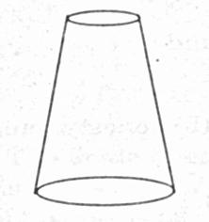
An athletic track 14m wide consists of two straight sections 120m long joining two semicircular ends whose inner radius is 35m. Calculate the area of shaded region.
- A fez, the cap used by the Turks, is shaped like the frustum of a cone. It its radius on the open side is 10 cm, radius at the upper base is 4 cm and its slant height is 15 cm. Find the area of the material used for making it.
- The angle of elevation of a cloud from a point 60 m above a lake is found to be 30° and the angle of depression of the reflection of the cloud in the lake is 60°. Find the height of the cloud from the surface of lake.
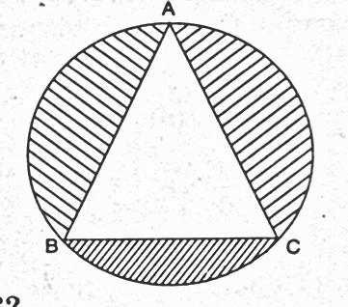
- In figure, an equilateral triangle has been inscribed in a circle of radius 6 cm. Find the area of the shaded region. [Use π= 3.14]
- From a point P, two tangents PA and PB are drawn to a circle with centre O. If OP = diameter of the circle show that ∆ APB is equilateral.
- Draw a right triangle in which the sides (other than hypotenuse) are of lengths 4 cm and 3 cm. Then construct another triangle whose sides are 3/5 times the sides of the given triangle.
- If the sum of first 4 terms of an A.P. is 40 and that of first 14 terms is 280. Find the sum of its first n terms.
*****************************
Career CBSE Classes # Get Online study Material and more Sample papers

